Linux Directory Structure
In Linux, everything is treated as a file even if it is a normal file, All the directories and files are stored under one root directory which is represented by a forward slash /.

Types of files in the Linux system

Linux categorizes files into different types based on their purpose, such as general data storage, system structure, or device representation.

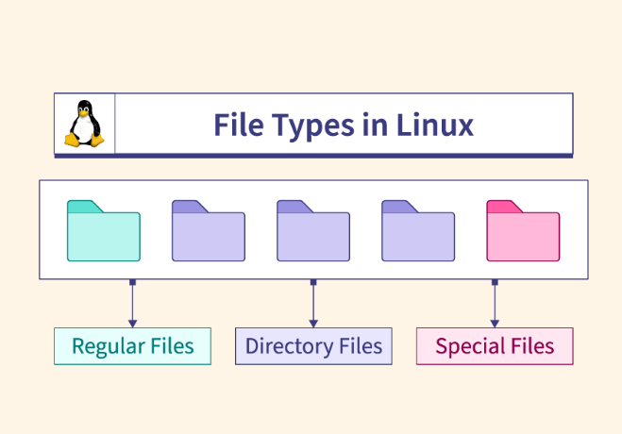
- Regular/General Files - It is also called ordinary files. It may be an image, video, program, or simple text file. These types of files can be in ASCII or Binary format. It is the most commonly used file in the Linux system.

- Directory Files - These types of files are a warehouse for other file types. It may be a directory file within a directory (subdirectory).
- Device/Special Files - In a Windows-like operating system, devices like CD-ROM and hard drives are represented as drive letters like F: G: H, whereas in the Linux system, devices are represented as files. As for example, /dev/sda1, /dev/sda2, and so on.

Directories associated with the root directory
These top-level directories under the root (/) form the foundation of the Linux file system, each serving a specific role in organizing system files, user data, and configurations.

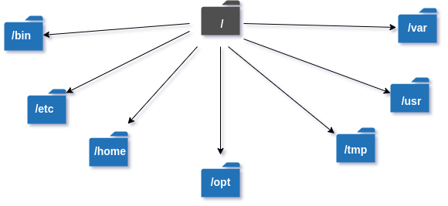

/ (Root Directory)
The top-most directory of the Linux filesystem. Everything starts from here. All the directories and files are stored under one root directory which is represented by a forward slash /.
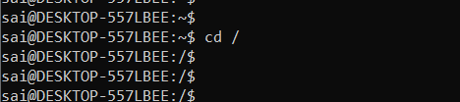

/bin (Essential User Binaries)
Contains binary executables.
Common linux commands you need to use in single-user modes are located under this directory.
Commands used by all the users of the system are located here e.g. ps, ls, ping, grep, cp

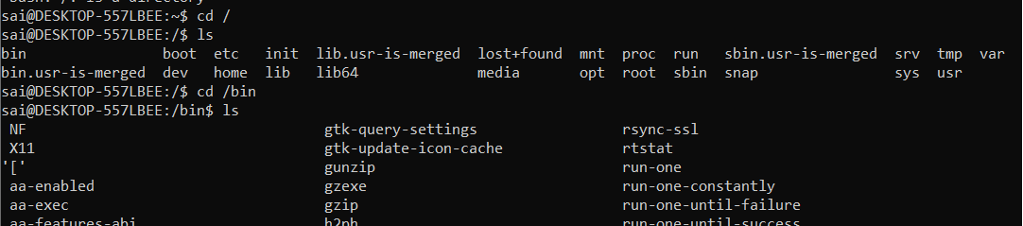

/sbin (System Binaries)
This directory holds administrative binaries like iptables, firewall management tools, fsck, init, route etc. These binaries are primarily for system administrators and typically require root privileges to execute.
- Just like /bin, /sbin also contains binary executables.
- The linux commands located under this directory are used typically by system administrators, for system maintenance purposes.

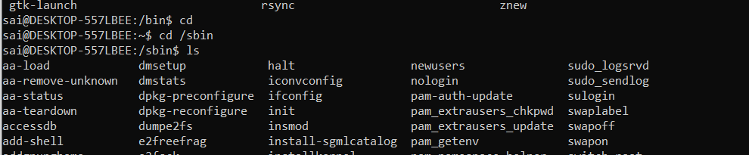

/boot (Boot Loader Files)
Bootloader files including the Linux kernel (vmlinuz) and GRUB config.
This directory stores all files required for booting the system. It includes the GRUB bootloader configuration and essential kernel files that are loaded during startup.
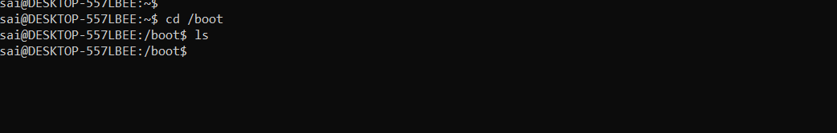

/etc (Configuration Files)
System-wide configuration files like fstab, hosts, sshd_config.
Short for "Editable Text Configuration," /etc contains configuration files for system applications, users, services, and tools or it contains the Host-specific system-wide configuration files. For example, user details like UID and local addresses are defined here.
- This also contains startup and shutdown shell scripts used to start/stop individual programs.
- Example: /etc/resolv.conf, /etc/logrotate.conf.

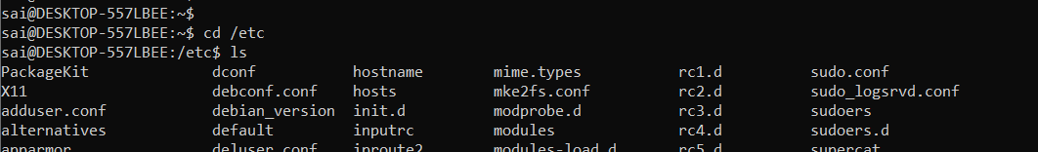

/home (Users' Home Directories)
Home directories for users, e.g., /home/saikiran.
Every non-root user has a personal directory inside /home. For example, if your username is anshu, your personal directory would be /home/anshu. Each user can create, delete, or modify files only in their own home directory and cannot access others’ home directories.
- Home directories for all users to store their personal files, containing saved files, personal settings, etc.

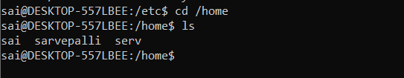

/root ()
Home directory for the root (superuser).
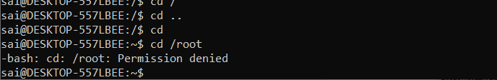

/var ()
The /var directory contains data that grows, shrinks, or gets modified regularly – unlike /etc or /usr which stay mostly static.
Variable data files such as logs, cache, and spool files. 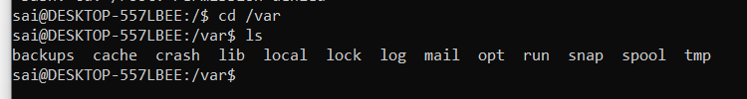

/usr ()
User applications and utilities: /usr/bin, /usr/lib, /usr/share. Contains binaries, libraries, documentation, and source-code for second level programs.

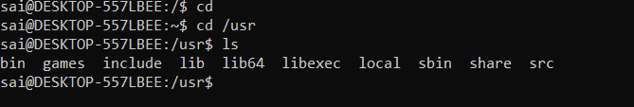

/opt ()
Third-party software and packages not part of the default system installation are stored in /opt. It includes their configuration and data files.
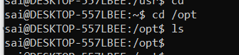

/media ()
Devices like USBs, CDs, and pen drives are mounted under /media. For example, when a CD-ROM is inserted (appeared in FHS-2.3), its details will appear here.

- Temporary mount directory for removable devices.

Mount point for removable media (USB, CD/DVD).
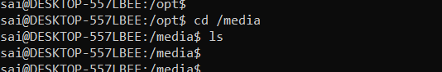

/mnt ()
When external drives are connected, they are temporarily mounted in /mnt. This is where their contents become accessible to the system.

- Temporary mount directory where sysadmins can mount filesystems.

Temporary mount point for filesystems.
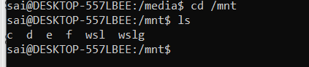

/dev ()
Device files representing hardware like /dev/sda.
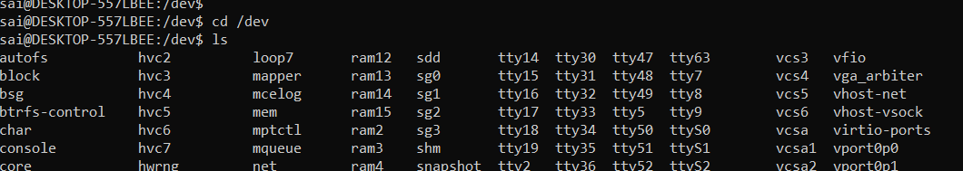

/proc ()
The /proc directory provides detailed information about system processes. Each process is assigned a unique ID and represented as a directory inside /proc.
Virtual filesystem providing process and kernel info.
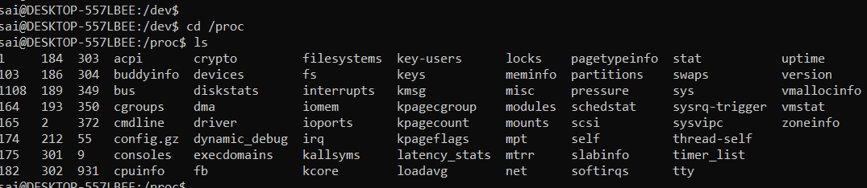

/sys ()
Virtual filesystem for kernel and hardware interaction.
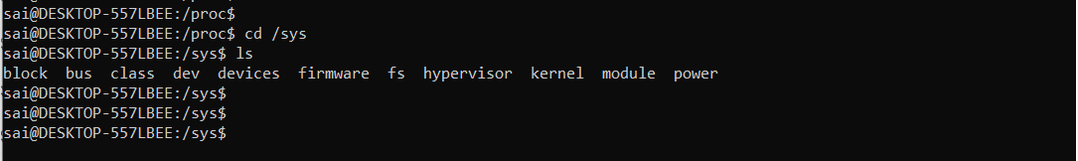

/lib ()
Applications require shared libraries to run, which are stored in /lib. These include dynamic libraries needed during runtime. For example, Apache server libraries are available here.
Essential shared libraries needed by /bin and /sbin.

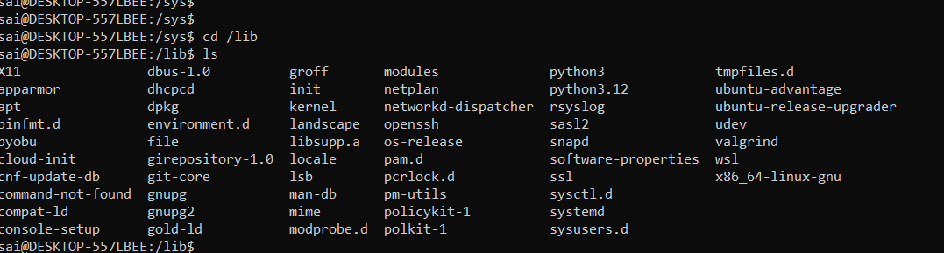

/tmp()
Programs create temporary files during execution, and these are stored in /tmp. These files are deleted automatically after the program finishes or when the system is restarted.
- Directory that contains temporary files created by system and users.
- Files under this directory are deleted when the system is rebooted.
